* **Develop a Web Application for Sustainable Development Goals (SDG) in India**

*  
* ***M.Sc. Agriculture Analytics***

**Submitted By:**

**Divya Prajapati**

ID: 202319024

**Harshil Ponkiya**

ID: 202319002

**Parth Patel**

ID: 202319007

**Abhay Kumar**

ID: 202319012

**Jatin Satani**

ID: 202319021

**Submitted To:**

**Mr. Santosh Gaikwad**

(Director - GeoSolutions, Nascent Info Tech.)

* **SDG India Index Overview**

The first edition of the SDG India Index was launched in December 2018.

The Index offers insights into the social, economic, and environmental status of the country and the States/UTs in their march towards achieving the SDGs. The Index has been designed in such a way that it is accessible to everyone - policymakers, civil society, businesses, and the general public.

* To rank the States/UTs based on their performance across the 16 SDGs. For 16 goals, all States/UTs were ranked. A composite score was also calculated, which ranked the States/UTs based on their overall performance across multiple Goals.
* To promote healthy competition among the States/UTs in their journey towards achieving the Global Goals.
* To support the States/UTs in identifying priority areas that demand more attention.
* To enable the States/UTs to learn from the good practices of their peers.
* To highlight data gaps in the statistical system of the States/UTs and identify the sectors in which robust and more frequent data needs to be collected.
* **Data Source**

The data related to SDG is sourced from the "NITI Aayog" website and linked to geographic locations using QGIS software.

Data Source Link:

<https://sdgindiaindex.niti.gov.in/#/ranking>

**The used datasets are also available in the Google Drive link.

In consideration of our area of interest, we have chosen the following five SDGs with a focus on:

* **Gender Equality**
* **Good Health**
* **No Poverty**
* **Quality Education**
* **Zero Hunger**
* **Database**

Upon completion of the preparation of all shapefiles, including the establishment of their respective indexes and geographic locations, the files are to be imported into the DB Manager and subsequently into the PostGIS database.

* **Geoserver**

Let's proceed by initializing the Geoserver and establishing a connection with our PostGIS-based Database.

Following this, we will create a store for our layers and publish all the layers.

**Subsequently, we will import styles from QGIS categorized as Achiever [100], Front Runner [65–99.99], Performer [50–64.99], and Aspirant [0–49.99].**

After importing the styling in Geoserver, it is imperative to republish all the layers with the new styling without delay.

Additionally, a Layers Preview with OpenLayers should be conducted to ensure the accuracy and effectiveness of the changes.

**Flowchart**

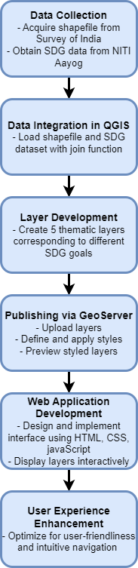

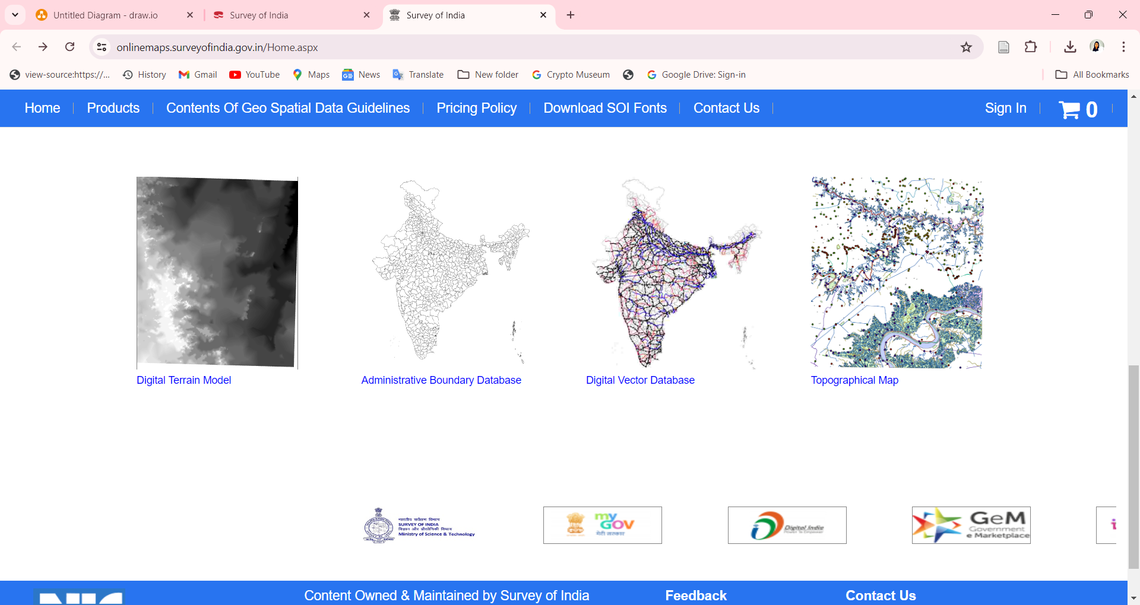

India Shapefile taken from survey of India website

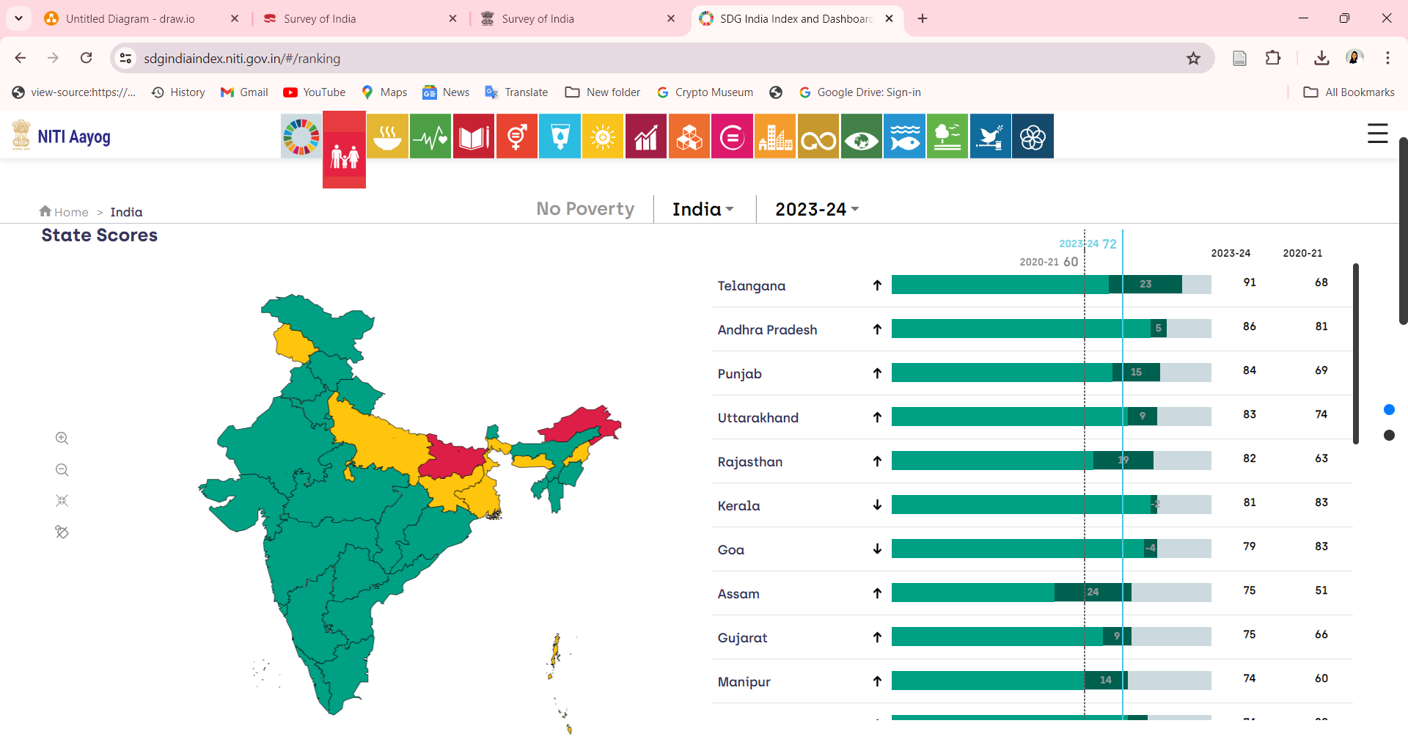

SDG data taken from NITI Aayog website



Appendix of Dataset

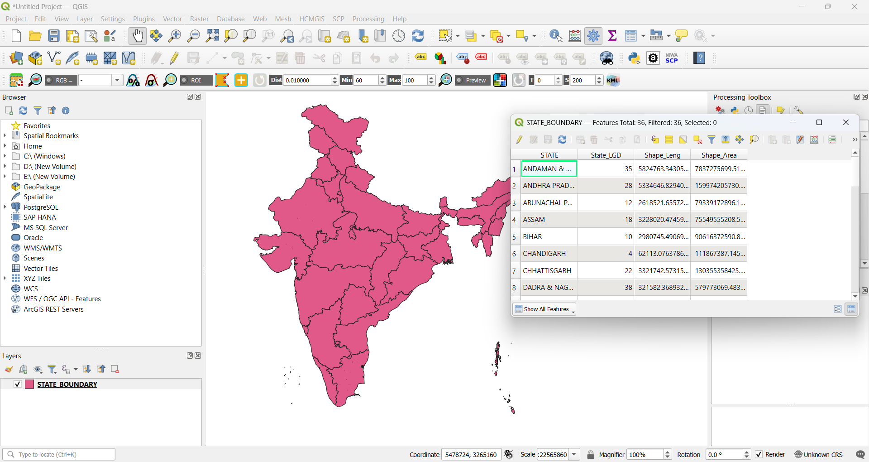

India shapefile loaded in QGIS (4 Columns)

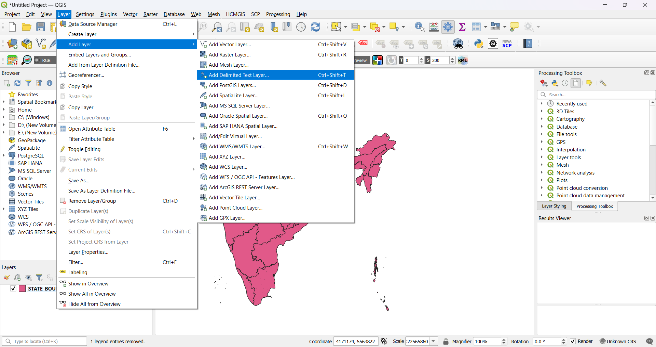

Added one layer named Delimited Text layer for uploading SDG excel file

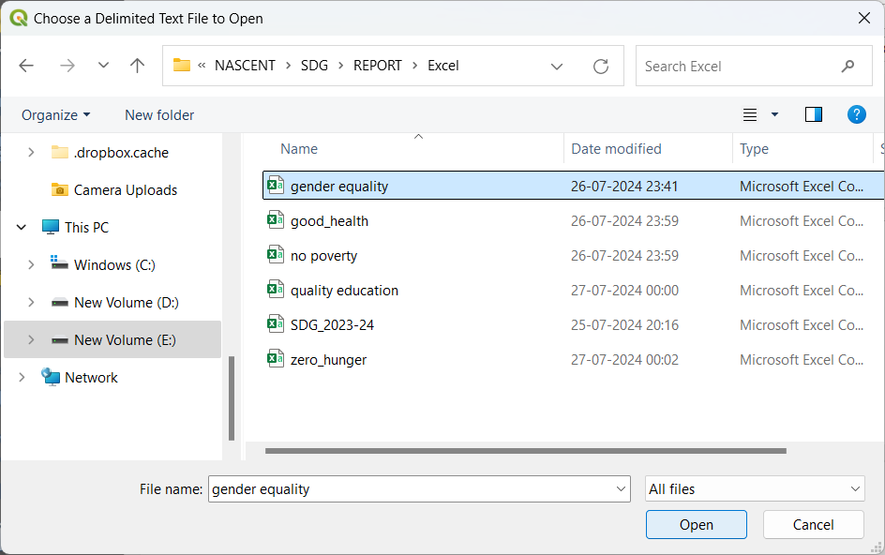

Add excel file named in QGIS

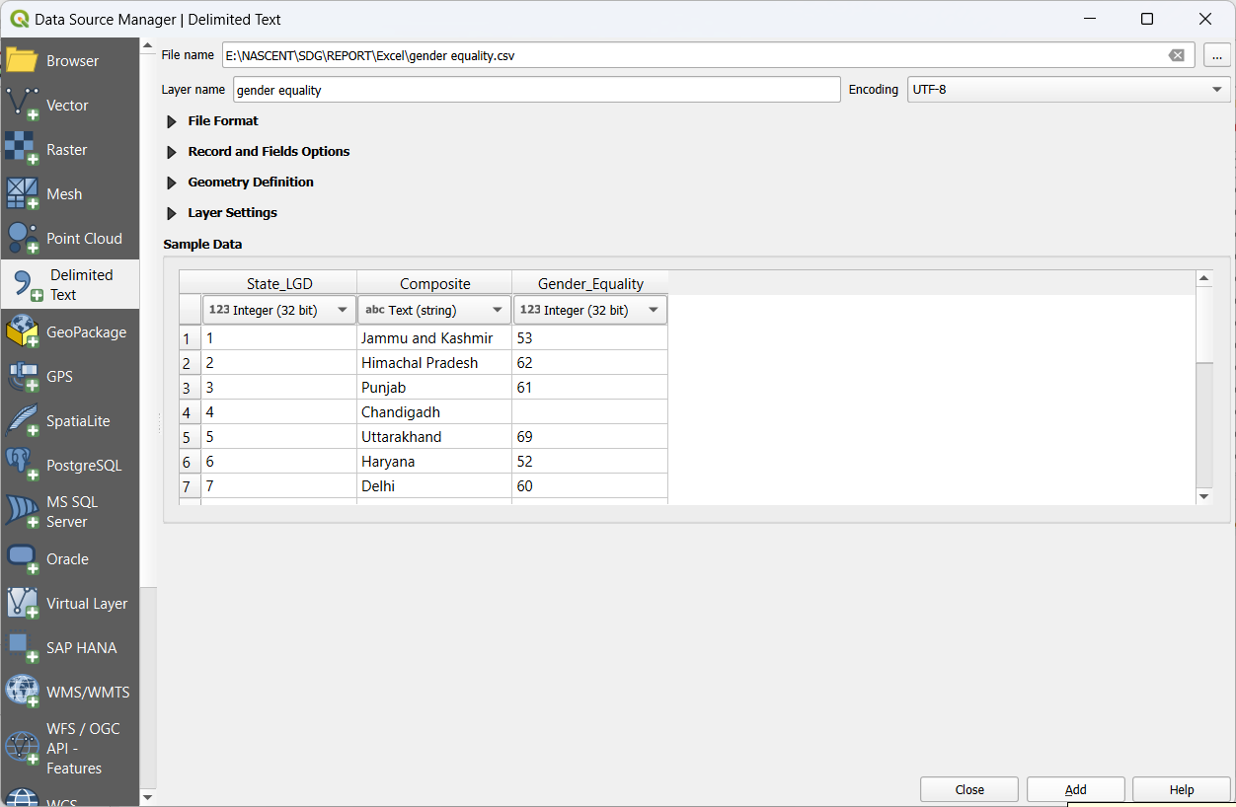

Load Excel file in QGIS

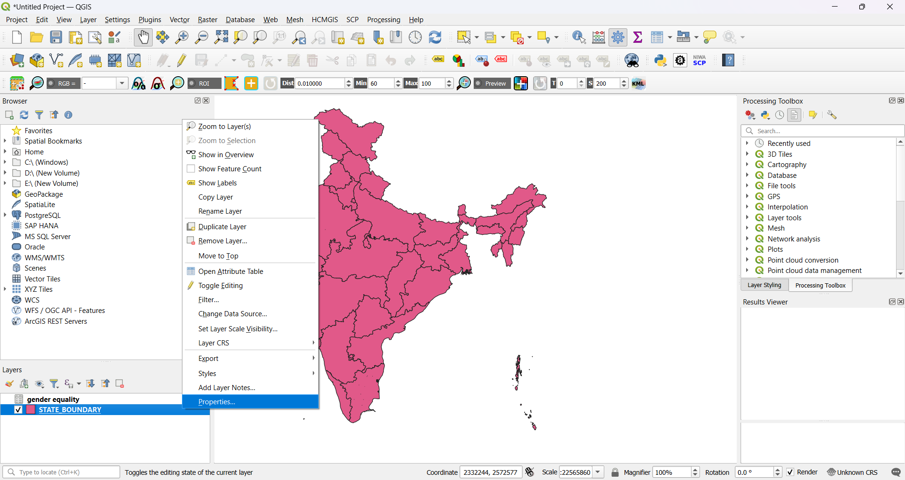

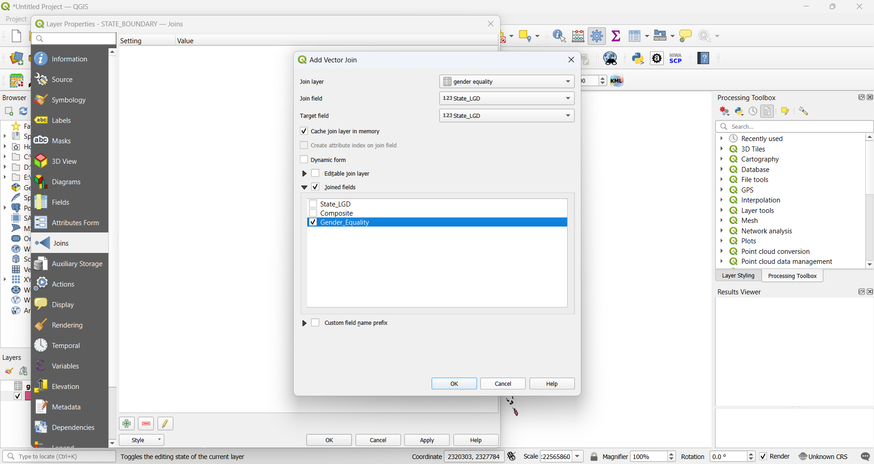

Merge Excel file and India shape file attribute table through Joins function

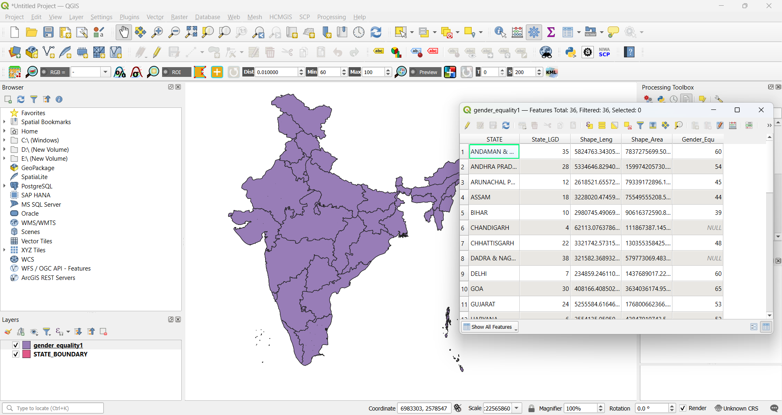

Added one column of SDG index in India shapefile

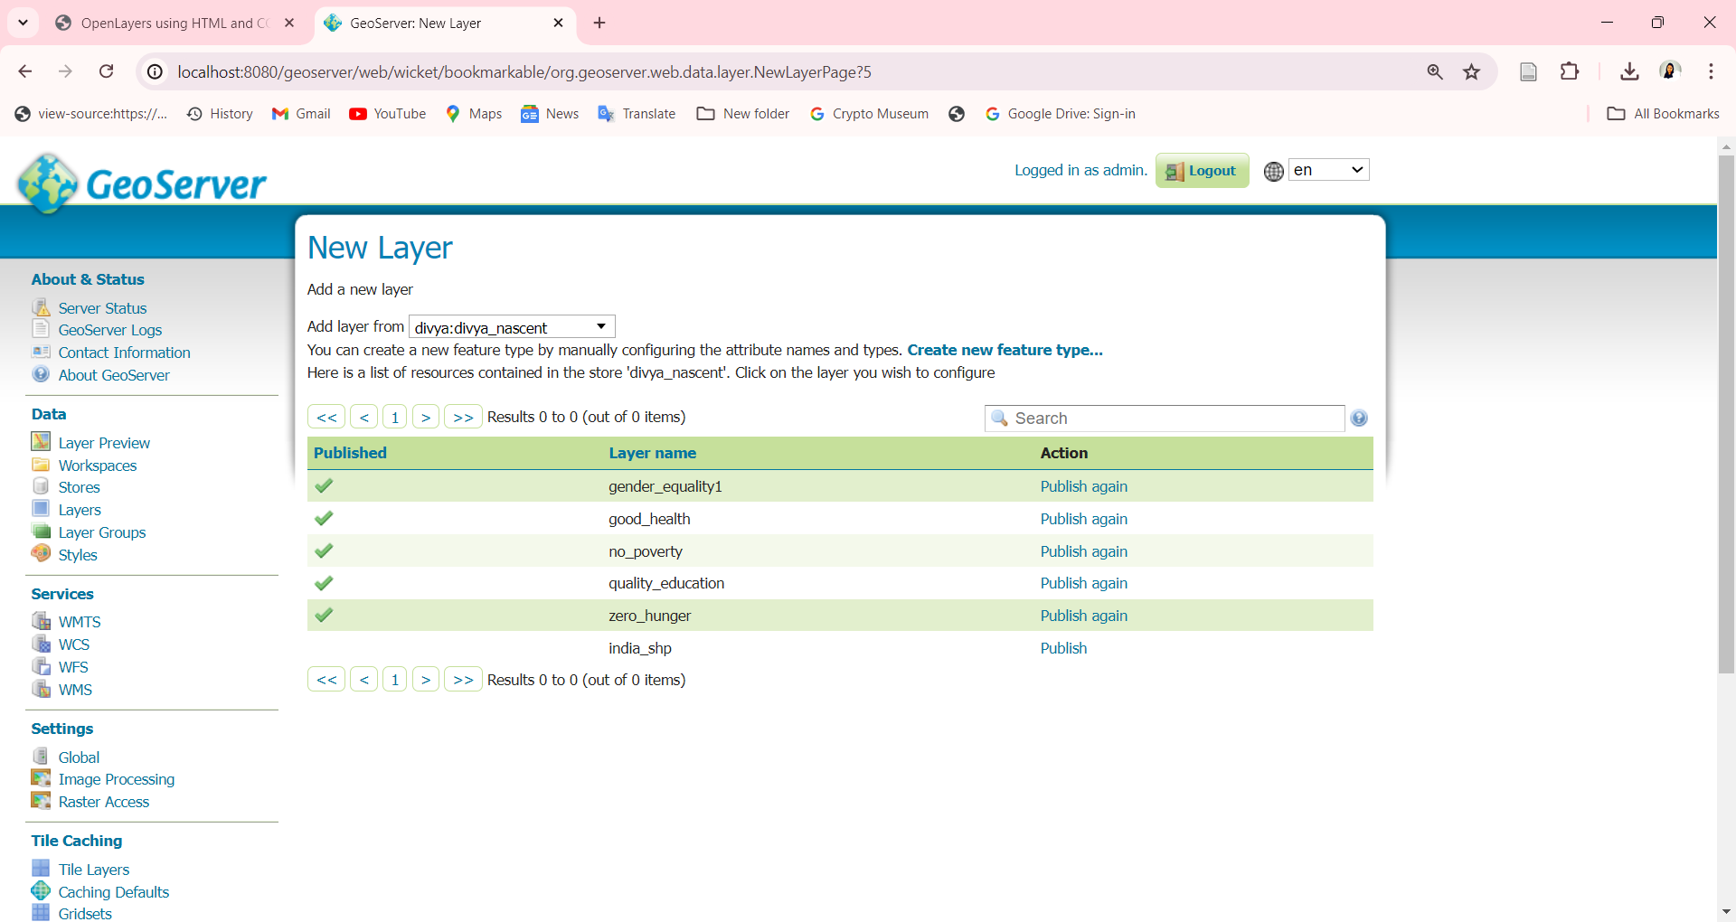

Add layers in GeoServer

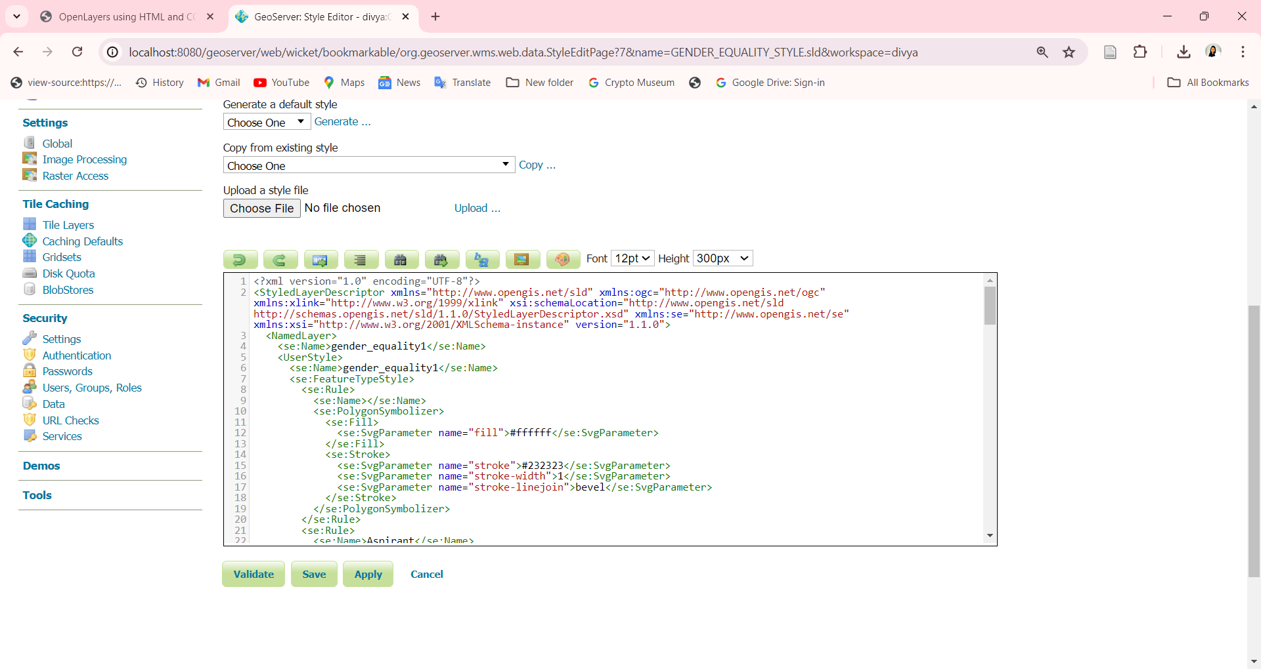

Add Style on uploaded Layers

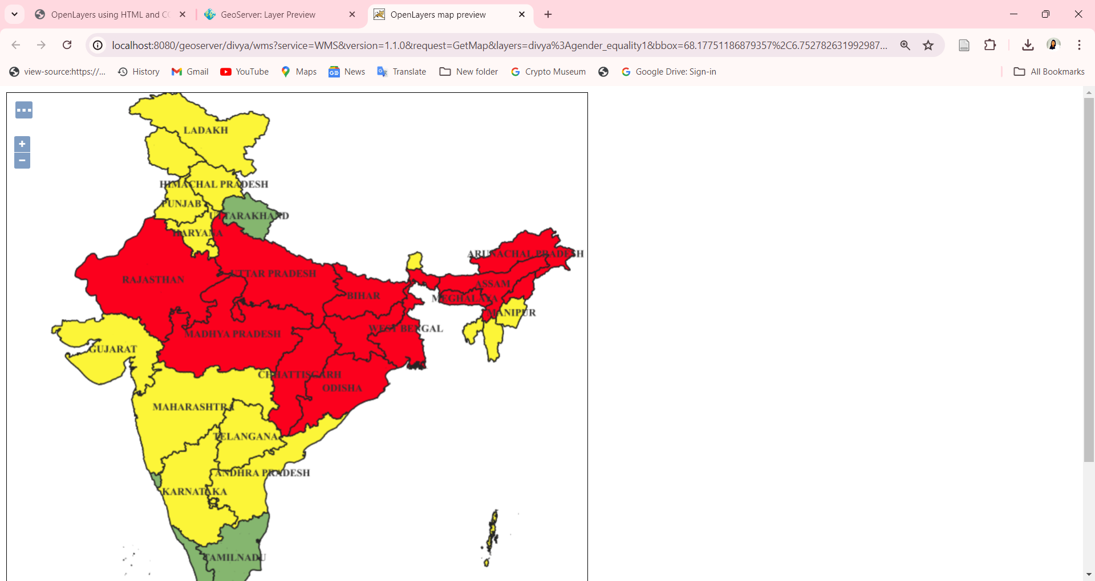

Layer preview of styled layer

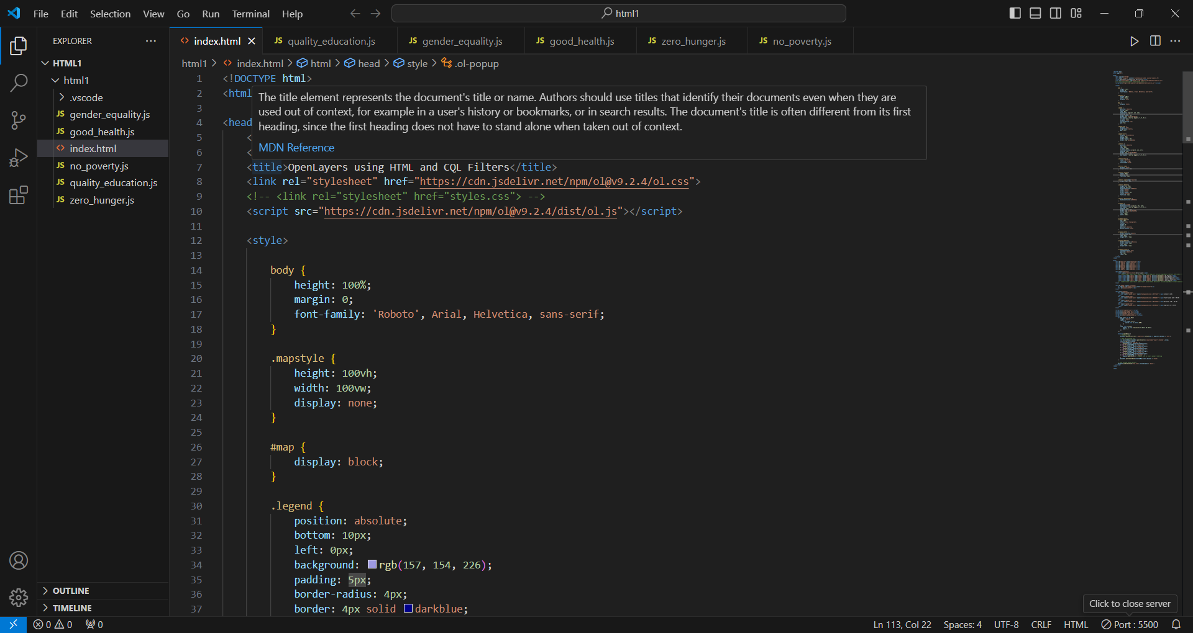

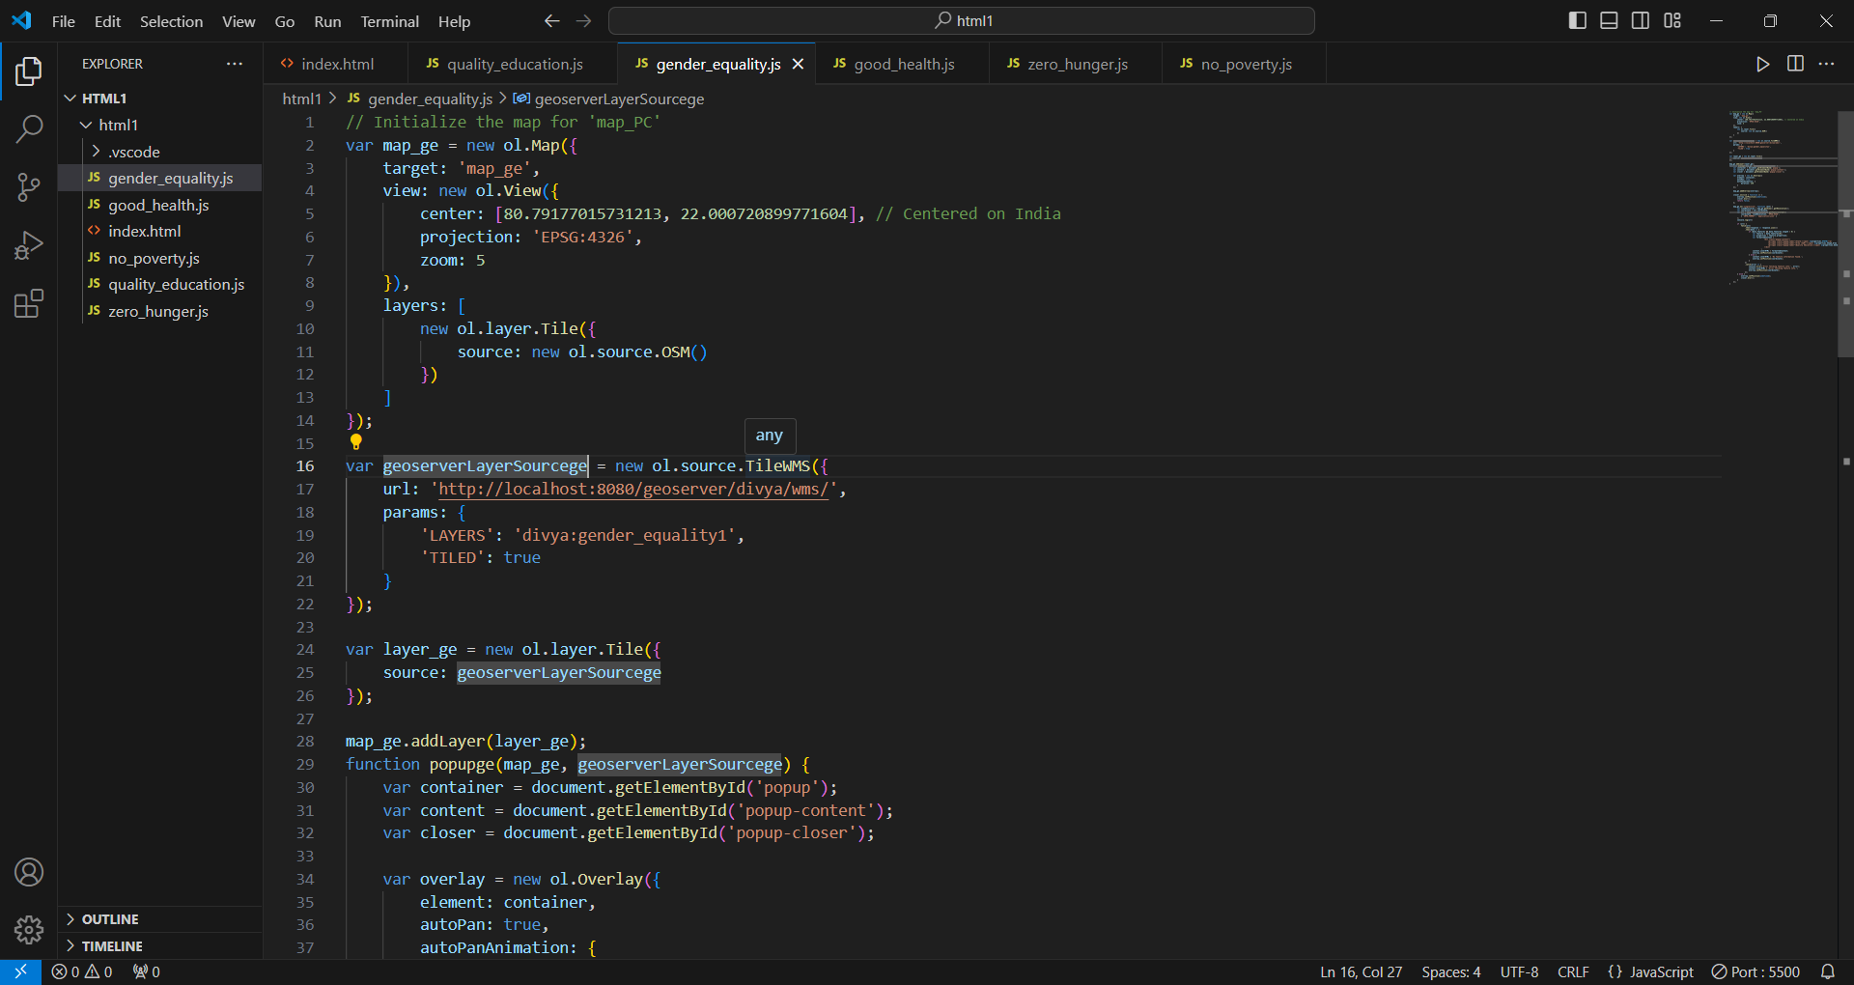

HTML, CSS, JavaScript code for OpenLayers

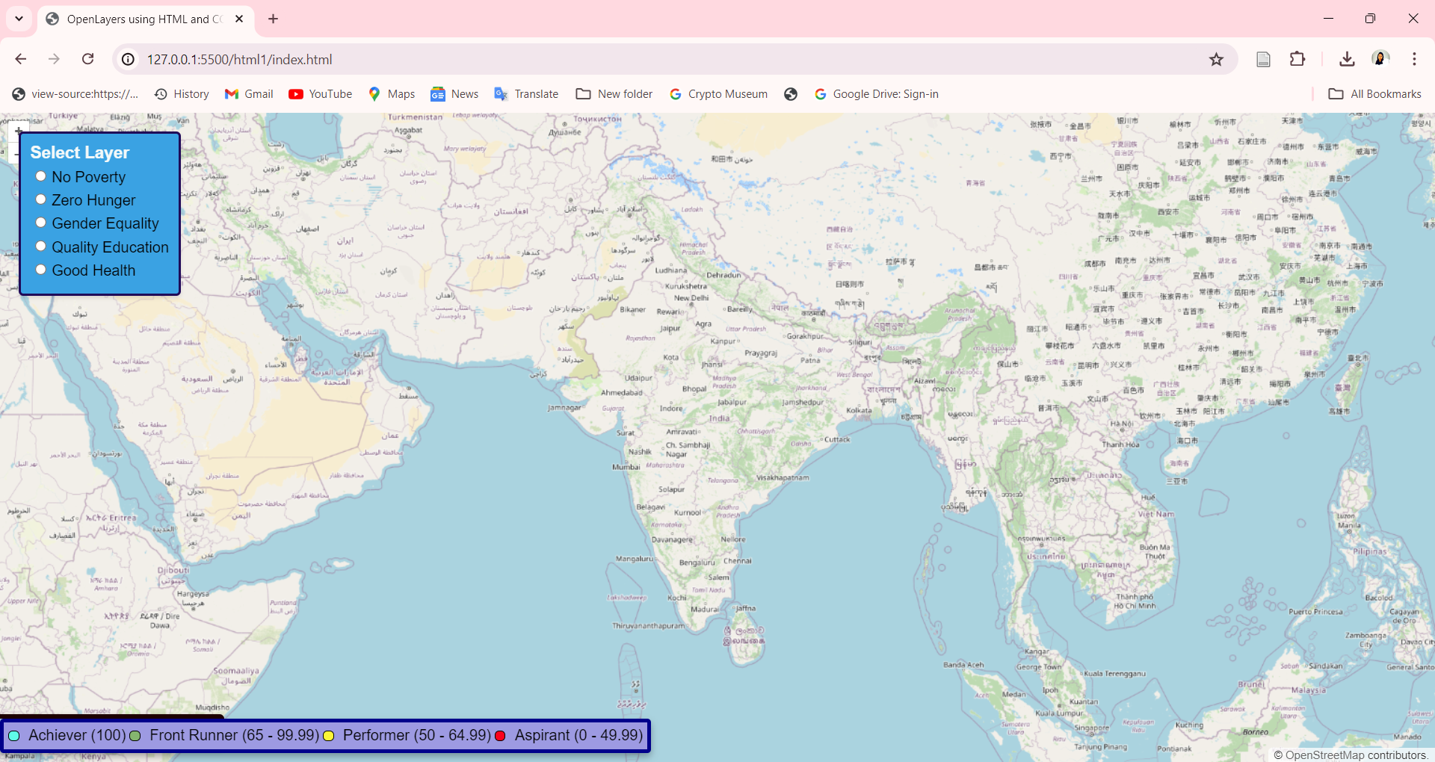

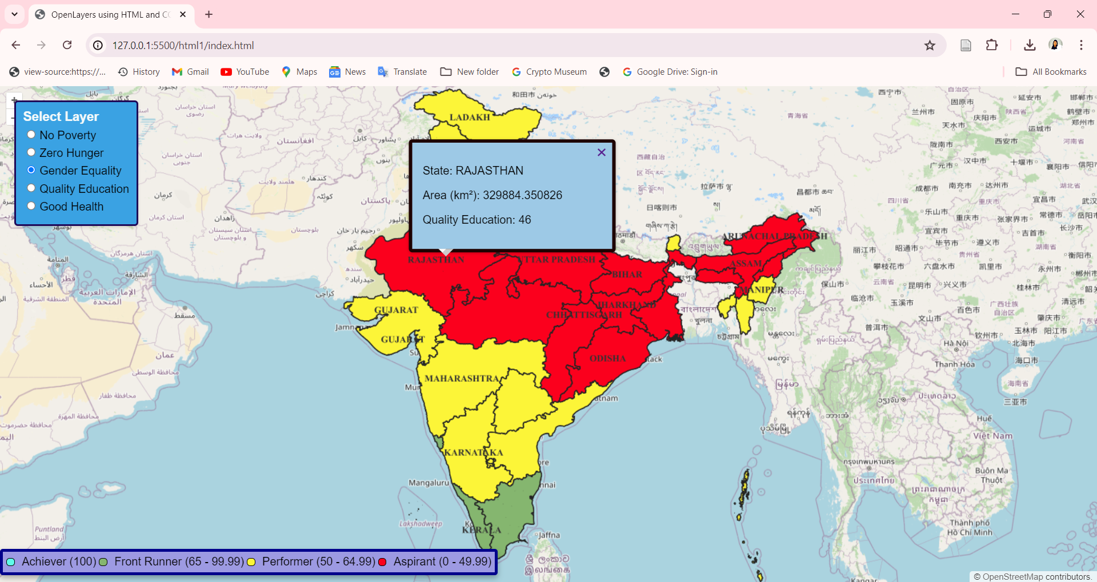

Results on OpenLayers

**Web Application Demo**

The demonstration video file for the developed web application addressing the Sustainable Development Goals (SDG) in India is readily accessible at the specified hyperlink:

<https://drive.google.com/file/d/1R03fYpF-euK5NZXzTjUm-htDoyyQU3tV/view?usp=sharing>

**References: -**

All the supporting files, including HTML, JavaScript, and SLD files, are available at the given link:

<https://drive.google.com/drive/folders/1zoMxokVcEUbpY2BHuehf2wSXSVTi6lPq?usp=sharing>

***Thank You!!!***